SAP Build MythBusters Script #1

SAP Build MythBuster#1: It's Only for Low-code Development
Video Assets in this folder:
- Message: SAP Build is a powerful tool for creating serious, enterprise-grade extensions at scale.
Smile More.
Footage | Talk Track | Screenshot
Intro | When most people hear "SAP Build," there is one thing usually comes to mind:  … low-code.
Low-Code  Video [0:49 – 1:00] | And they’re not entirely wrong, that's how SAP Build first started: drag-and-drop tools to create apps and customize processes  We then also later added AI-powered development. | 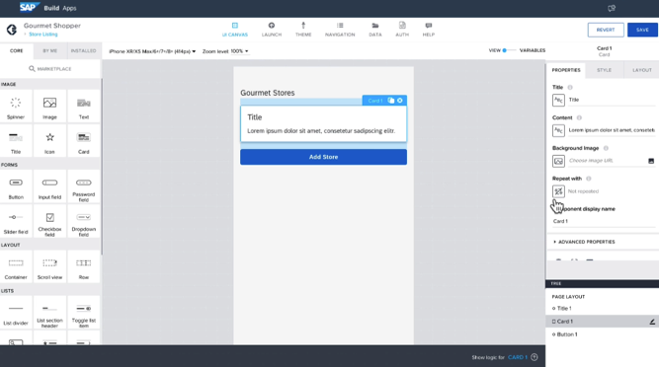
Full Stack Development | …. But \  that's only one part of the story. We heard our customers loud and clear: you need to tackle a broader spectrum of development projects at scale.  That’s why SAP Build has evolved into a full-stack development platform spanning low-code, pro-code, and generative AI.  This empowers your entire team to use the tools that best fit their skills and collaborate seamlessly on a single platform, | (Visual)
Transition to Demo | Let’s walk through an example: building an enterprise-grade extension with SAP Build
Build Lobby  Lobby-Mythbysters1.mp4 | Everything starts from the SAP Build lobby,  here your team can choose the tools that fit the use case best. Build a wide range of solutions with SAP Build—from full-stack apps to front end extensions, and mobile applications. | 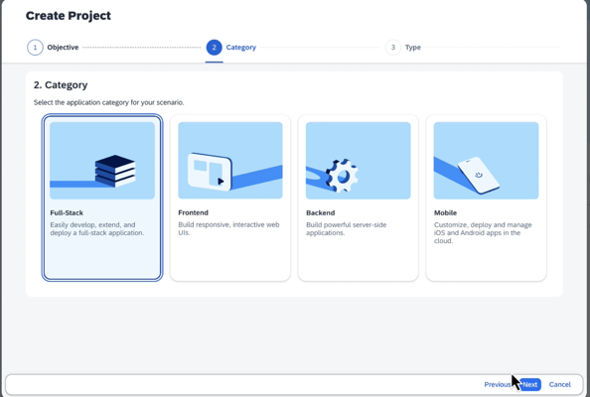
ABAP Business Object  [YouTube video - 2:39 – 3:09] | First, let's create the back end. Jump directly into an ABAP Cloud environment to create upgrade-safe extensions.  To enforce new business rules in ABAP RESTful application programing model, you can extend the business object with new validation logic. | 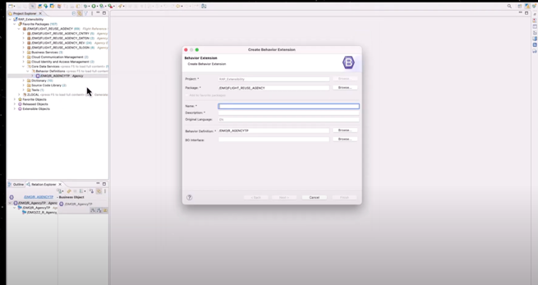
CAP  LCAP [17:38 – 17:50] | If you prefer to work in the Cloud Application Programming model,  you can add custom business logic to your service with natural language  and write the code directly. | 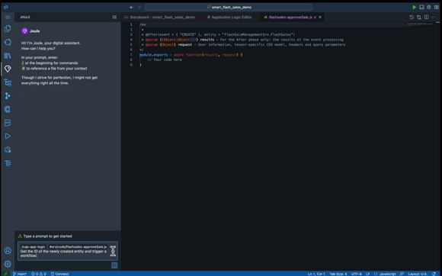
UI Generation  SAP Build Code Extension.mp4  [3:49 – 4:01] | Now for the user interface. Using a template gives us a great head start. We'll select the list report to build out your Fiori app. | 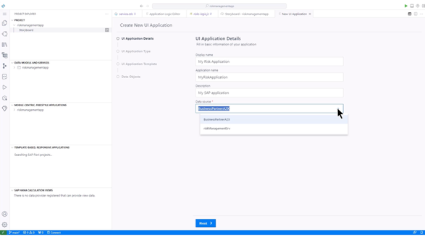
Testing  SAP Build Code Extension.mp4  [4:51 – 4:55] | Once completed, you can instantly preview and test your application—whether it’s a Fiori app, a custom UI5 interface, or a solution for web and mobile. | 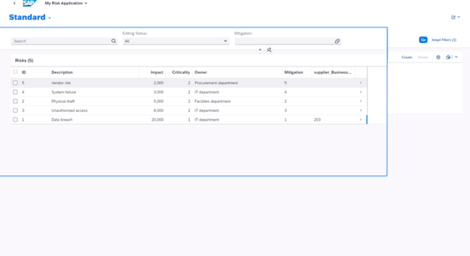
Governance & LCM  LCAP video.mp4 [19:51- 20:09] | You can ensure your governance and lifecycle management remain solid as your team ships new releases. And you can also push changes from SAP Build to your GitHub repository, triggering automated scans, test suites, and validation for release | 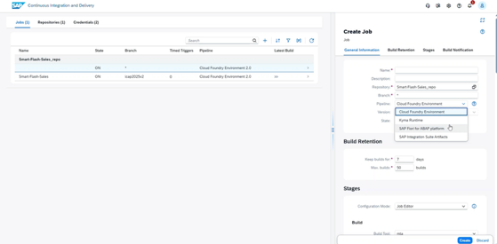
Outro | What’s more, you can do all this without switching between tools. Move seamlessly between natural language prompting, visual editing, and code to build enterprise-grade app  And honestly, we're just scratching the surface of what's possible.  If you'd like to learn more, I highly encourage you to check out the SAP Build trial, where you can go hands-on with our tutorials  Seeya soon,

